#include <iostream>

using namespace std;

int cube(int y);

int main()

{

    int x{0};

    for (x = 1; x <= 10; x++)

    {

        cout << cube(x) << endl;

    }

}

int cube(int y)

{

    return y \* y \* y;

}

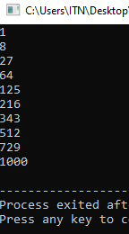

#include <iostream>

#include <cmath>

#include <iomanip>

using namespace std;

int main()

{

    cout <<"the square root of 9 is= "<< sqrt(9) << endl;

    cout <<"the log of 2.718282 is= "<< log(2.718282) << endl;

    cout <<"the absolute value of -5.1 is ="<< fabs(-5.1) << endl;

    cout <<"the round off of 9.2 is= " <<ceil(9.2) << endl;

    cout <<"round off of 9.2 is= "<< floor(9.2) << endl;

    cout <<"answer of 2 raise to power 7 is= "<<pow(2,7)<<endl;

    cout<<"the sin of 30 is= "<<sin(30)<<endl;

    cout<<"the cos of 60 is= "<<cos(60)<<endl;

    cout<<"the tan of 30 is= "<<tan(30)<<endl;

    return 0;

}

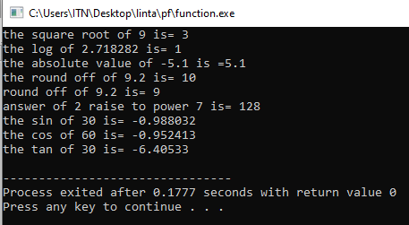

#include <iostream>

#include <cmath>

using namespace std;

const double PI{3.14};

inline double sphereVolume(const double radius)

{

    return (4.0/3.0)\*PI\*pow(radius,3);

}

int main()

{

    cout << "enter the length of radius of sphere= ";

    double radiusValue;

    cin>>radiusValue;

    cout<<"the voulume of sphere is= "<<sphereVolume(radiusValue)<<endl;

    return 0;

}

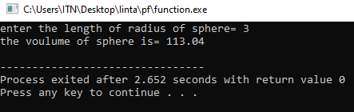

Function call stack

#include<iostream>

using namespace std;

int square(int);

int main(){

int a {10};

cout<<a<<" "<<"squared gives: "<<square(a)<<endl;

}

int square(int x){

return x\*x;

}

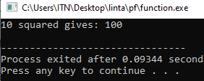

#include <iostream>

using namespace std;

inline double cube(const double side)

{

    return side \* side \* side;

}

int main()

{

    double sideValue;

    cout << "enter the side length of your cube: ";

    cin >> sideValue;

    cout << "volume of cube with side " << sideValue << " "

         << "is"

         << " " << cube(sideValue) << endl;

}

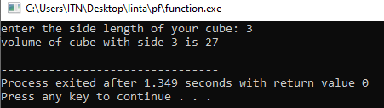

#include <iostream>

using namespace std;

int square(int x)

{

    cout << "square of integer" << x << "is";

    return x \* x;

}

double square(double y)

{

    cout << "square of double " << y << "is";

    return y \* y;

}

int main()

{

    cout << square(7);

    cout<<endl;

    cout<<square(7.5);

    cout<<endl;

}